**22AIE115 UID Task 2**

**Railway Information Centre & Food**

AIM:

To goal is to create a web page for Railway Ticket Booking and Information Centre Webpage using simple html tags which contains the details of trains route map and destination details provided full description. It also has the feature of online food ordering facility which gets delivered in the respective train where order is placed.

TAGS USED:

* <html></html>
* <body></body>
* <h1></h1>
* <h2></h2>
* <a></a>
* <img>
* <table></table>
* <tr></tr>
* <th></th>
* <td></td>

SOURCE CODE:

Homepage:

<html>

    <style>

        body

        {

           background-image: url('Train.jpg');

           background-attachment: fixed;

           background-size: 100% 100%;

        }

    </style>

    <body style = "background-color: rgba(247,247,247,255)">

        <p style="font-size: 90; text-align: center;"><b>PRAZZO RAILWAY TICKET BOOKINGS</b></p>

        <marquee style="font-size: 25;" scrollamount=10>

            <a href="TrainListpage.html">

                Click here to book Tickets..................................................................................................Click here to book Tickets

        </a></p></body></marquee>

        <p></p>

    </body>

</html>

Train List Page:

<html>

    <style>

        body

        {

           background-image: url('Train2.jpg');

           background-attachment: fixed;

           background-size: 100% 100%;

        }

    </style>

    <body>

        <table style="width: 700px; border: 1000cm;">

            <tr>

                <th style="text-align:center; font-size: 50px;color: white; background-color: black;">Train Name</th>

                <th style="text-align:center; font-size: 50px;color: white;background-color: black;">Train Number</th>

            </tr>

            <tr>

                <td></td>

                <td></td>

            </tr>

            <tr>

                <td style="text-align:center; font-size: 25px; background-color: aliceblue;"><a href="https://www.makemytrip.com/railways/chennai-egmore-rameswaram-rameswaram-exp-22661-train.html" style="color:darkblue">Rameswaram Express</a></td>

                <td style="text-align:center; font-size: 25px; background-color: aliceblue;">22661</td>

            </tr>

            <tr>

                <td></td>

                <td></td>

            </tr>

            <tr>

                <td style="text-align:center; font-size: 25px;background-color: aliceblue;"><a href="https://www.goibibo.com/trains/tuticorin-exp-16236-detail/" style="color:darkblue">Tuticorn Express</a></td>

                <td style="text-align:center; font-size: 25px;background-color: aliceblue;">16236</td>

            </tr>

            <tr>

                <td></td>

                <td></td>

            </tr>

            <tr>

                <td style="text-align:center; font-size: 25px;background-color: aliceblue;"><a href="https://www.ixigo.com/trains/16587" style="color:darkblue">Ypr Bkn Express</a></td>

                <td style="text-align:center; font-size: 25px;background-color: aliceblue;">16587</td>

            </tr>

            <tr>

                <td></td>

                <td></td>

            </tr>

            <tr>

                <td style="text-align:center; font-size: 25px;background-color: aliceblue;"><a href="https://www.goibibo.com/trains/ms-rmm-express-16751-detail/" style="color:darkblue">MS RMM Express</a></td>

                <td style="text-align:center; font-size: 25px;background-color: aliceblue;">16751</td>

            </tr>

            <tr>

                <td></td>

                <td></td>

            </tr>

            <tr>

                <td style="text-align:center; font-size: 25px;background-color: aliceblue;"><a href="https://www.goibibo.com/trains/pearl-city-(muthu-nagar)-super-fast-express-12694-detail/" style="color:darkblue">Pearl City Express</a></td>

                <td style="text-align:center; font-size: 25px;background-color: aliceblue;">12694</td>

            </tr>

            <tr>

                <td></td>

                <td></td>

            </tr>

            <tr>

                <td style="text-align:center; font-size: 25px; background-color: aliceblue;"><a href="https://www.goibibo.com/trains/pandian-express-12638-detail/" style="color:darkblue">Pandian Express</a></td>

                <td style="text-align:center; font-size: 25px; background-color: aliceblue;">12638</td>

            </tr>

            <tr>

                <td></td>

                <td></td>

            </tr>

            <tr>

                <td style="text-align:center; font-size: 25px; background-color: aliceblue;"><a href="https://www.ixigo.com/trains/16865" style="color:darkblue">Uzhavan Express</a></td>

                <td style="text-align:center; font-size: 25px; background-color: aliceblue;">16865</td>

            </tr>

        </table>

        <p style="color: yellowgreen; font-size: 25px; text-align: left;"><b>After booking the tickets successfully, click below to see the food items available </b></p>

        <a href="FoodPage.html" style="color: black; font-size: 20px; background-color: white;">MENU</a>

    </body>

</html>

Food List Page:

<html>

    <style>

        body

        {

            background-image: url("Food.jpg");

            background-attachment: fixed;

            background-size: 100% 100%;

        }

    </style>

    <body>

        <style>

            table, th, td{

                width :50%;

                height: 10%;

                border: 2px solid white;

            }

        </style>

        <table style="width:700px; border:1000cm">

            <tr>

                <th style="text-align:center; font-size: 30px;color: white;"><b>List of Meals</b></th>

                <th style="text-align:center; font-size: 30px;color: white;"><b>Price (in INR)</b></th>

            </tr>

            <tr>

                <td style="text-align:center; font-size: 15px;color: white;">Plate Meals</th>

                <td style="text-align:center; font-size: 15px;color: white;">50</th>

            </tr>

            <tr>

                <td style="text-align:center; font-size: 15px;color: white;">Jeera Rice</th>

                <td style="text-align:center; font-size: 15px;color: white;">40</th>

            </tr>

            <tr>

                <td style="text-align:center; font-size: 15px;color: white;">Veg Biriyani</th>

                <td style="text-align:center; font-size: 15px;color: white;">60</th>

            </tr>

            <tr>

                <td style="text-align:center; font-size: 15px;color: white;">Veg Pulav</th>

                <td style="text-align:center; font-size: 15px;color: white;">60</th>

            </tr>

            <tr>

                <td style="text-align:center; font-size: 15px;color: white;">Hyderabadi Biriyani</th>

                <td style="text-align:center; font-size: 15px;color: white;">60</th>

            </tr>

            <tr>

                <td style="text-align:center; font-size: 15px;color: white;">Veg Fried Rice</th>

                <td style="text-align:center; font-size: 15px;color: white;">50</th>

            </tr>

            <tr>

                <td style="text-align:center; font-size: 15px;color: white;">Veg Schezwan Fried Rice</th>

                <td style="text-align:center; font-size: 15px;color: white;">50</th>

            </tr>

            <tr>

                <td style="text-align:center; font-size: 15px;color: white;">Punjabi Thali</th>

                <td style="text-align:center; font-size: 15px;color: white;">70</th>

            </tr>

            <tr>

                <td style="text-align:center; font-size: 15px;color: white;">Plain Paratha</th>

                <td style="text-align:center; font-size: 15px;color: white;">15</th>

            </tr>

            <tr>

                <td style="text-align:center; font-size: 15px;color: white;">Aloo Paratha</th>

                <td style="text-align:center; font-size: 15px;color: white;">20</th>

            </tr>

            <tr>

                <td style="text-align:center; font-size: 15px;color: white;">Bhindi Masala</th>

                <td style="text-align:center; font-size: 15px;color: white;">40</th>

            </tr>

            <tr>

                <td style="text-align:center; font-size: 15px;color: white;">Paneer Butter Masala</th>

                <td style="text-align:center; font-size: 15px;color: white;">50</th>

            </tr>

            <tr>

                <td style="text-align:center; font-size: 15px;color: white;">Veg Khofta Masala</th>

                <td style="text-align:center; font-size: 15px;color: white;">50</th>

            </tr>

            <tr>

                <td style="text-align:center; font-size: 15px;color: white;">Mushroom Gravy</th>

                <td style="text-align:center; font-size: 15px;color: white;">50</th>

            </tr>

            <tr>

                <td style="text-align:center; font-size: 15px;color: white;">Daal Makhni</th>

                <td style="text-align:center; font-size: 15px;color: white;">40</th>

            </tr>

            <tr>

                <td style="text-align:center; font-size: 15px;color: white;">Paalak Panner</th>

                <td style="text-align:center; font-size: 15px;color: white;">50</th>

            </tr>

        </table>

        <p style="color: yellowgreen; font-size: 25px; text-align: center;"><b>Enjoy the variety of meals provided</b></p>

    </body>

</html>

OUTPUT:

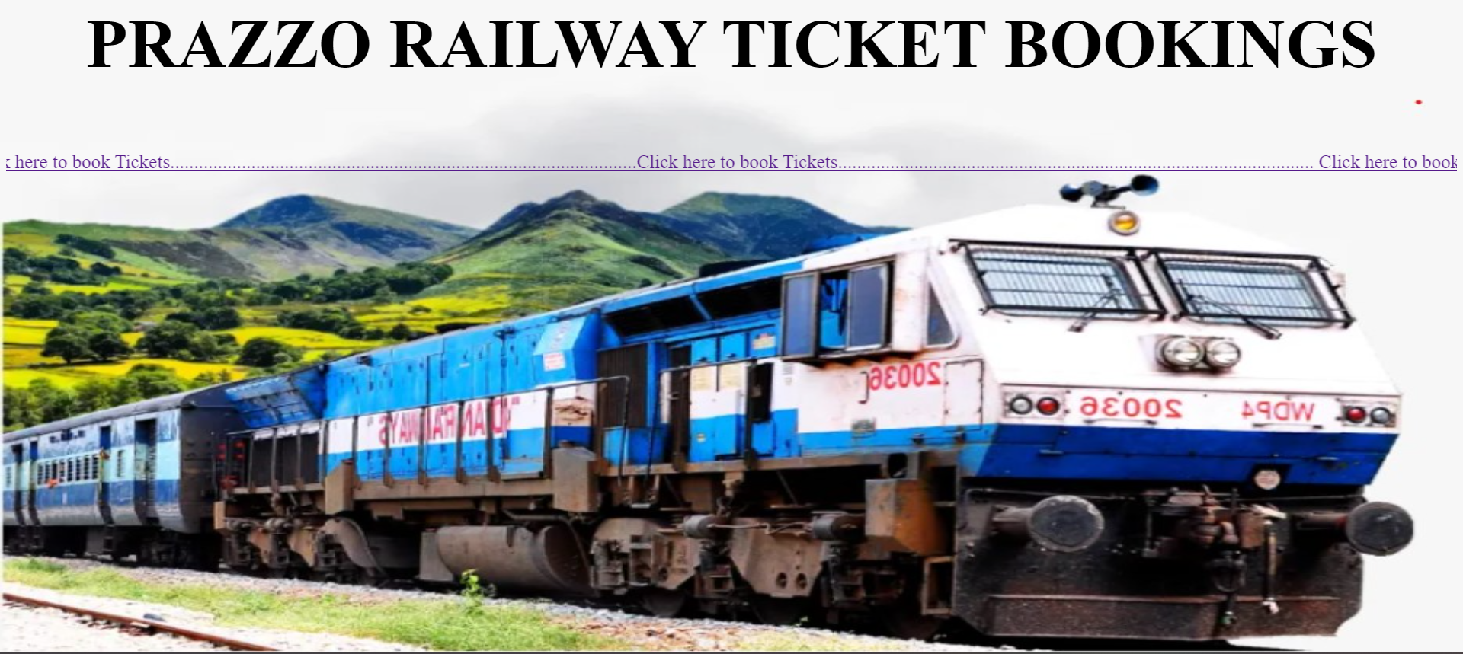

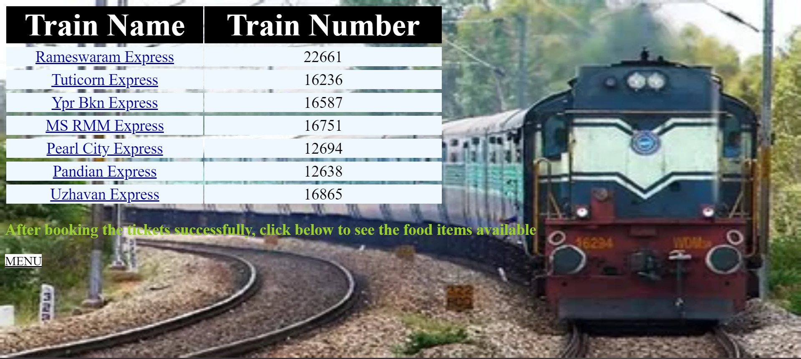

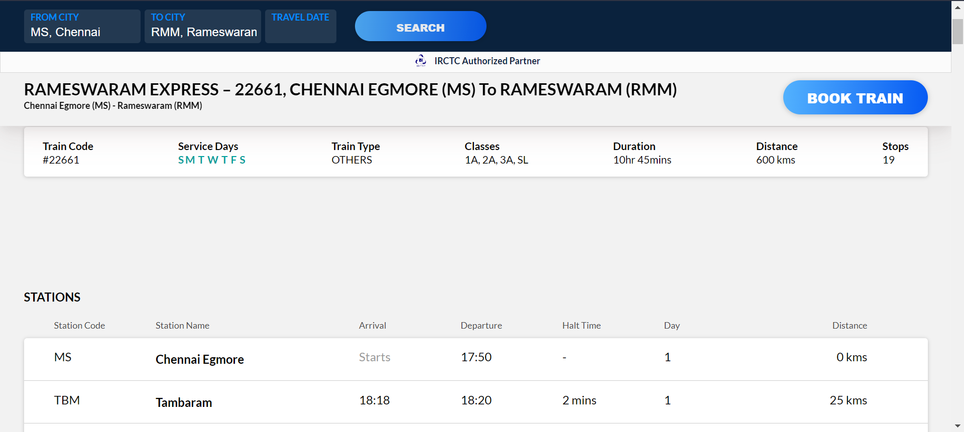

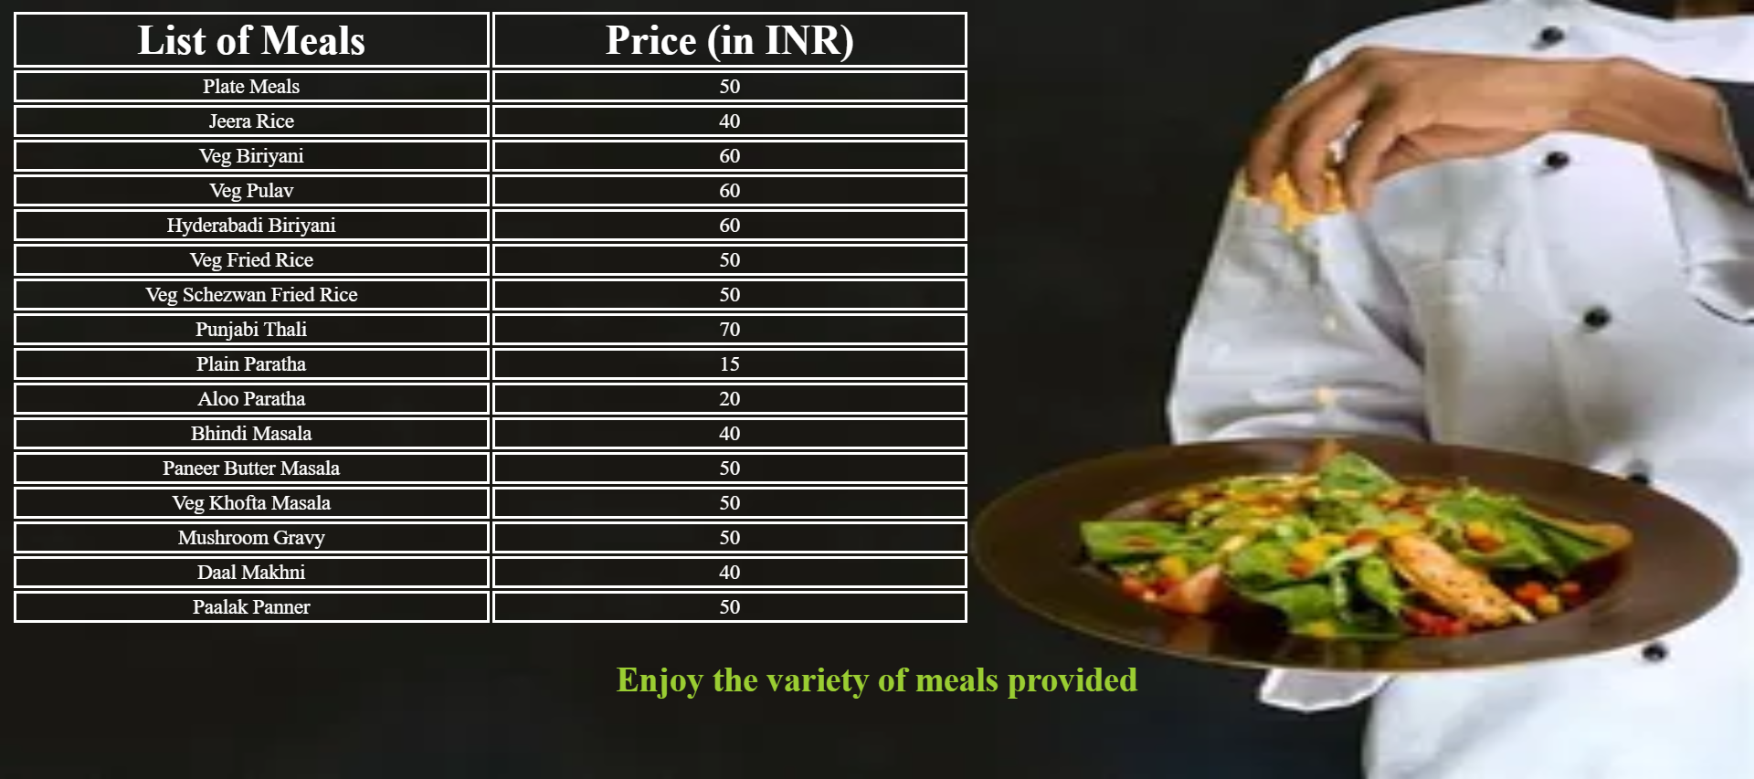

INFERENCE:

This is a HTML code to create a web page for Railway Ticket Booking and Information Centre Webpage using simple html tags which contains the details of trains route map and destination details provided full description. It also has the feature of online food ordering facility which gets delivered in the respective train where order is placed.